Milestone #1 (September 23, 2020)

When I first began planning for this piece, I had already made a plan to use software that allows me to do some photo editing like lightroom/photoshop as well as 3D modeling software like Blender. I wanted to make it look like a photo since most of my memories were in the form of photographs and I felt it was very fitting to create something that looked like a photograph. Below is the early version of what I wanted my piece to look like. Maybe like a photograph you could enter. My idea was to have a lot of flowers and butterflies surrounding the main image like a picture frame.

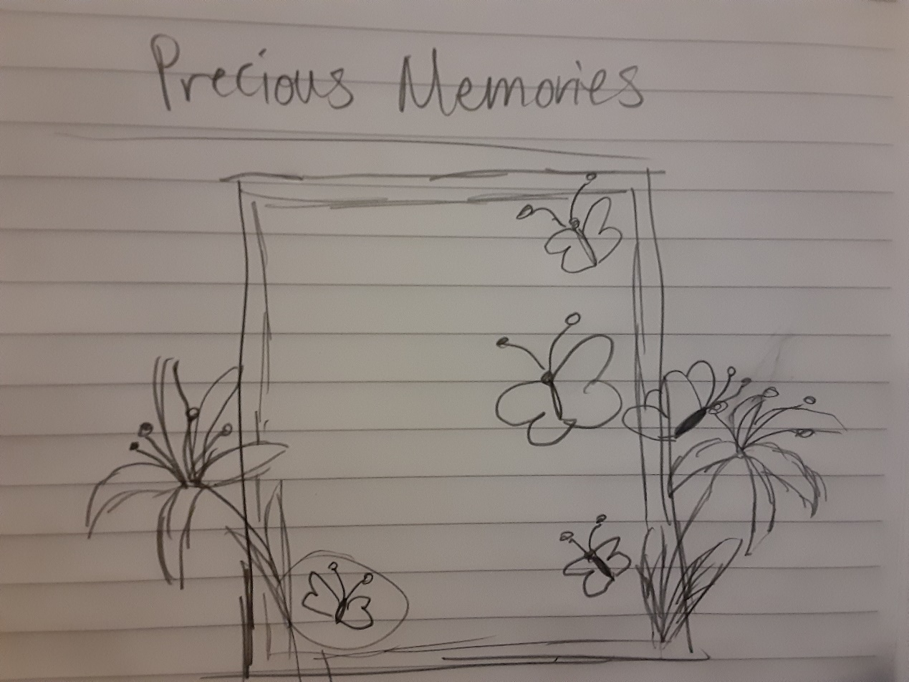

I began to work on models for the flowers and figuring out where I wanted to place my main image. This was what my blender project looked like at this point:

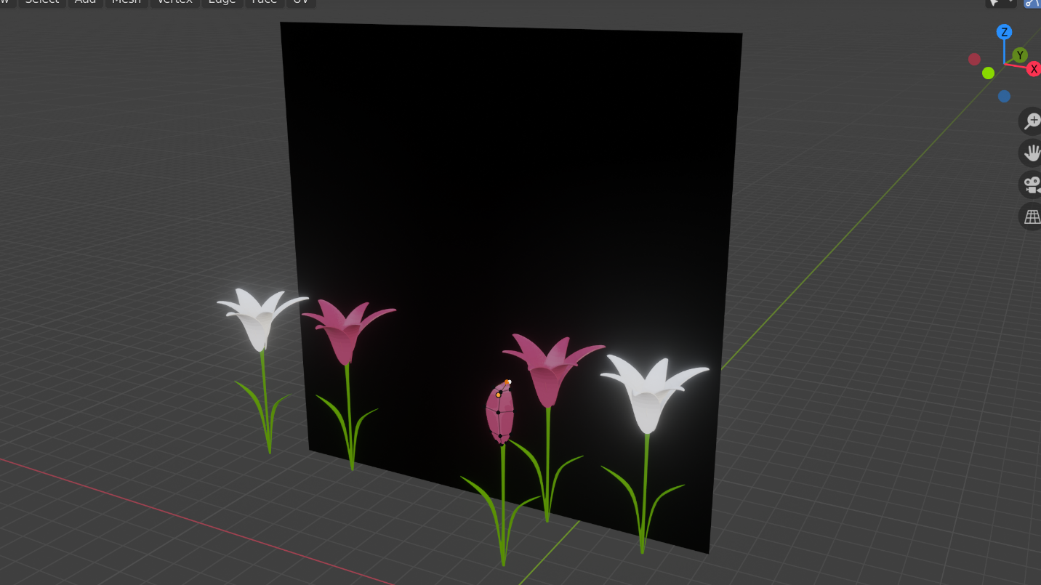

With the Blender part already at good progress, I set myself to work looking for the last thing that I needed to work on getting: my textures. Below are some of the images I was able to find that included my grandmother. Some are recent while others are several years old even dating back to photos of my grandmother and mother before my parents even got married.

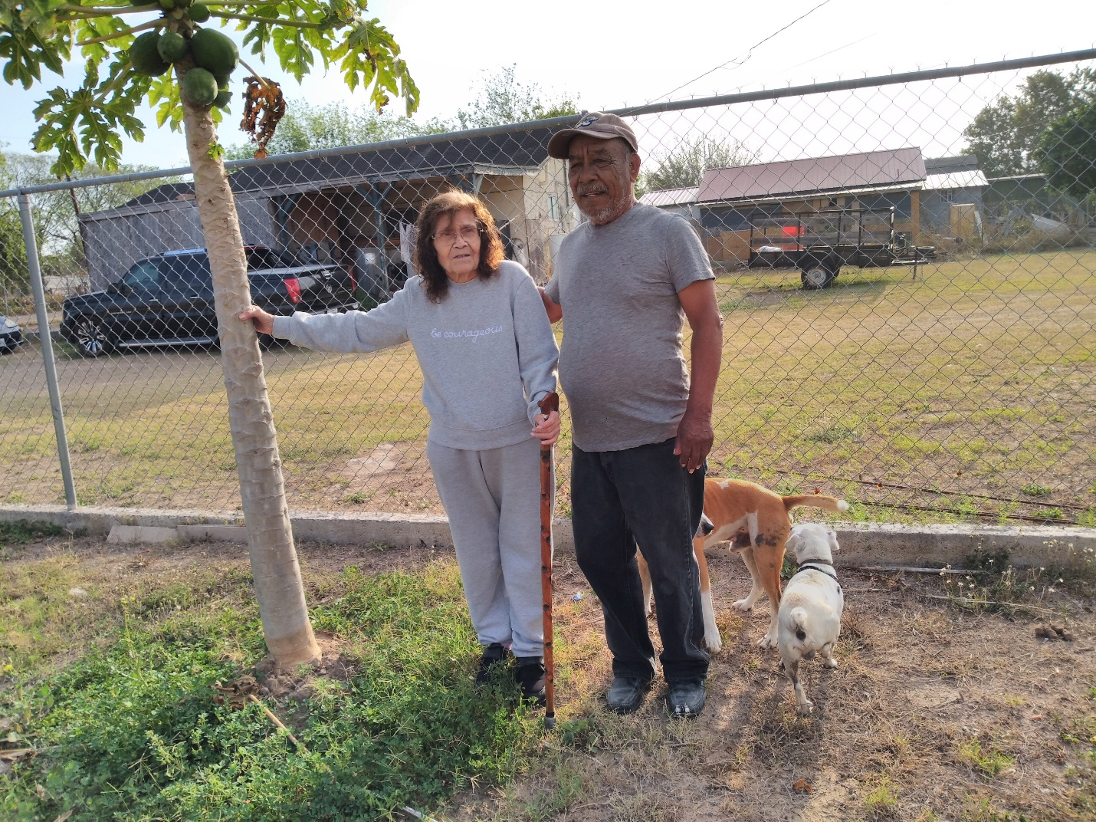

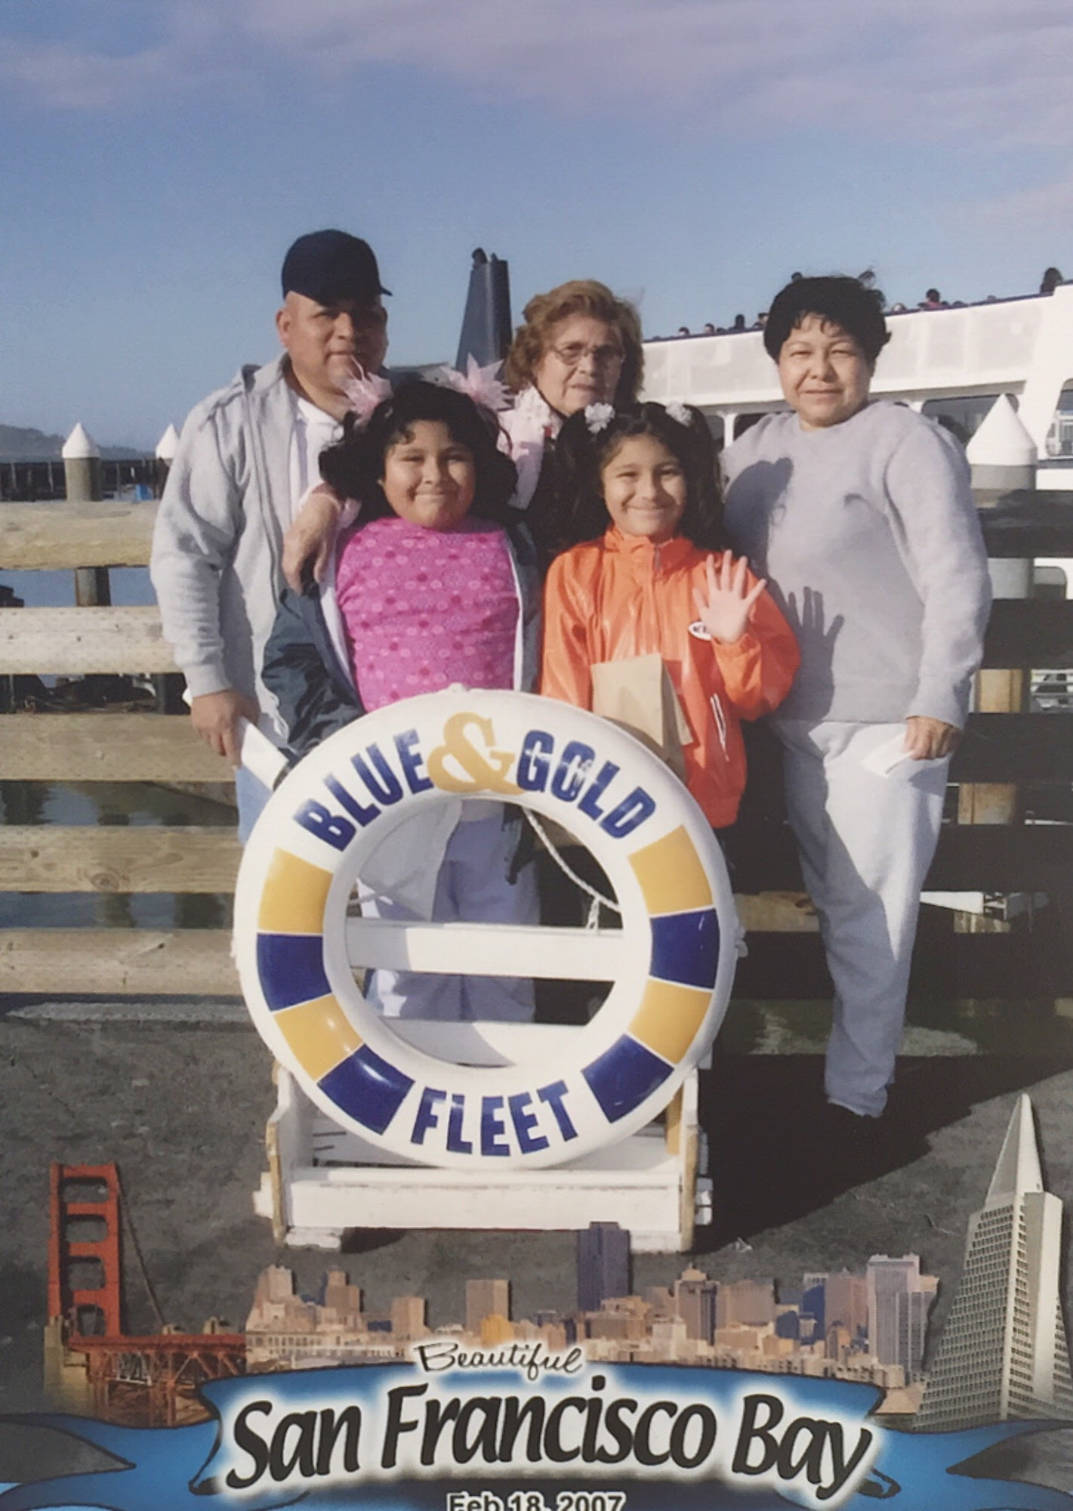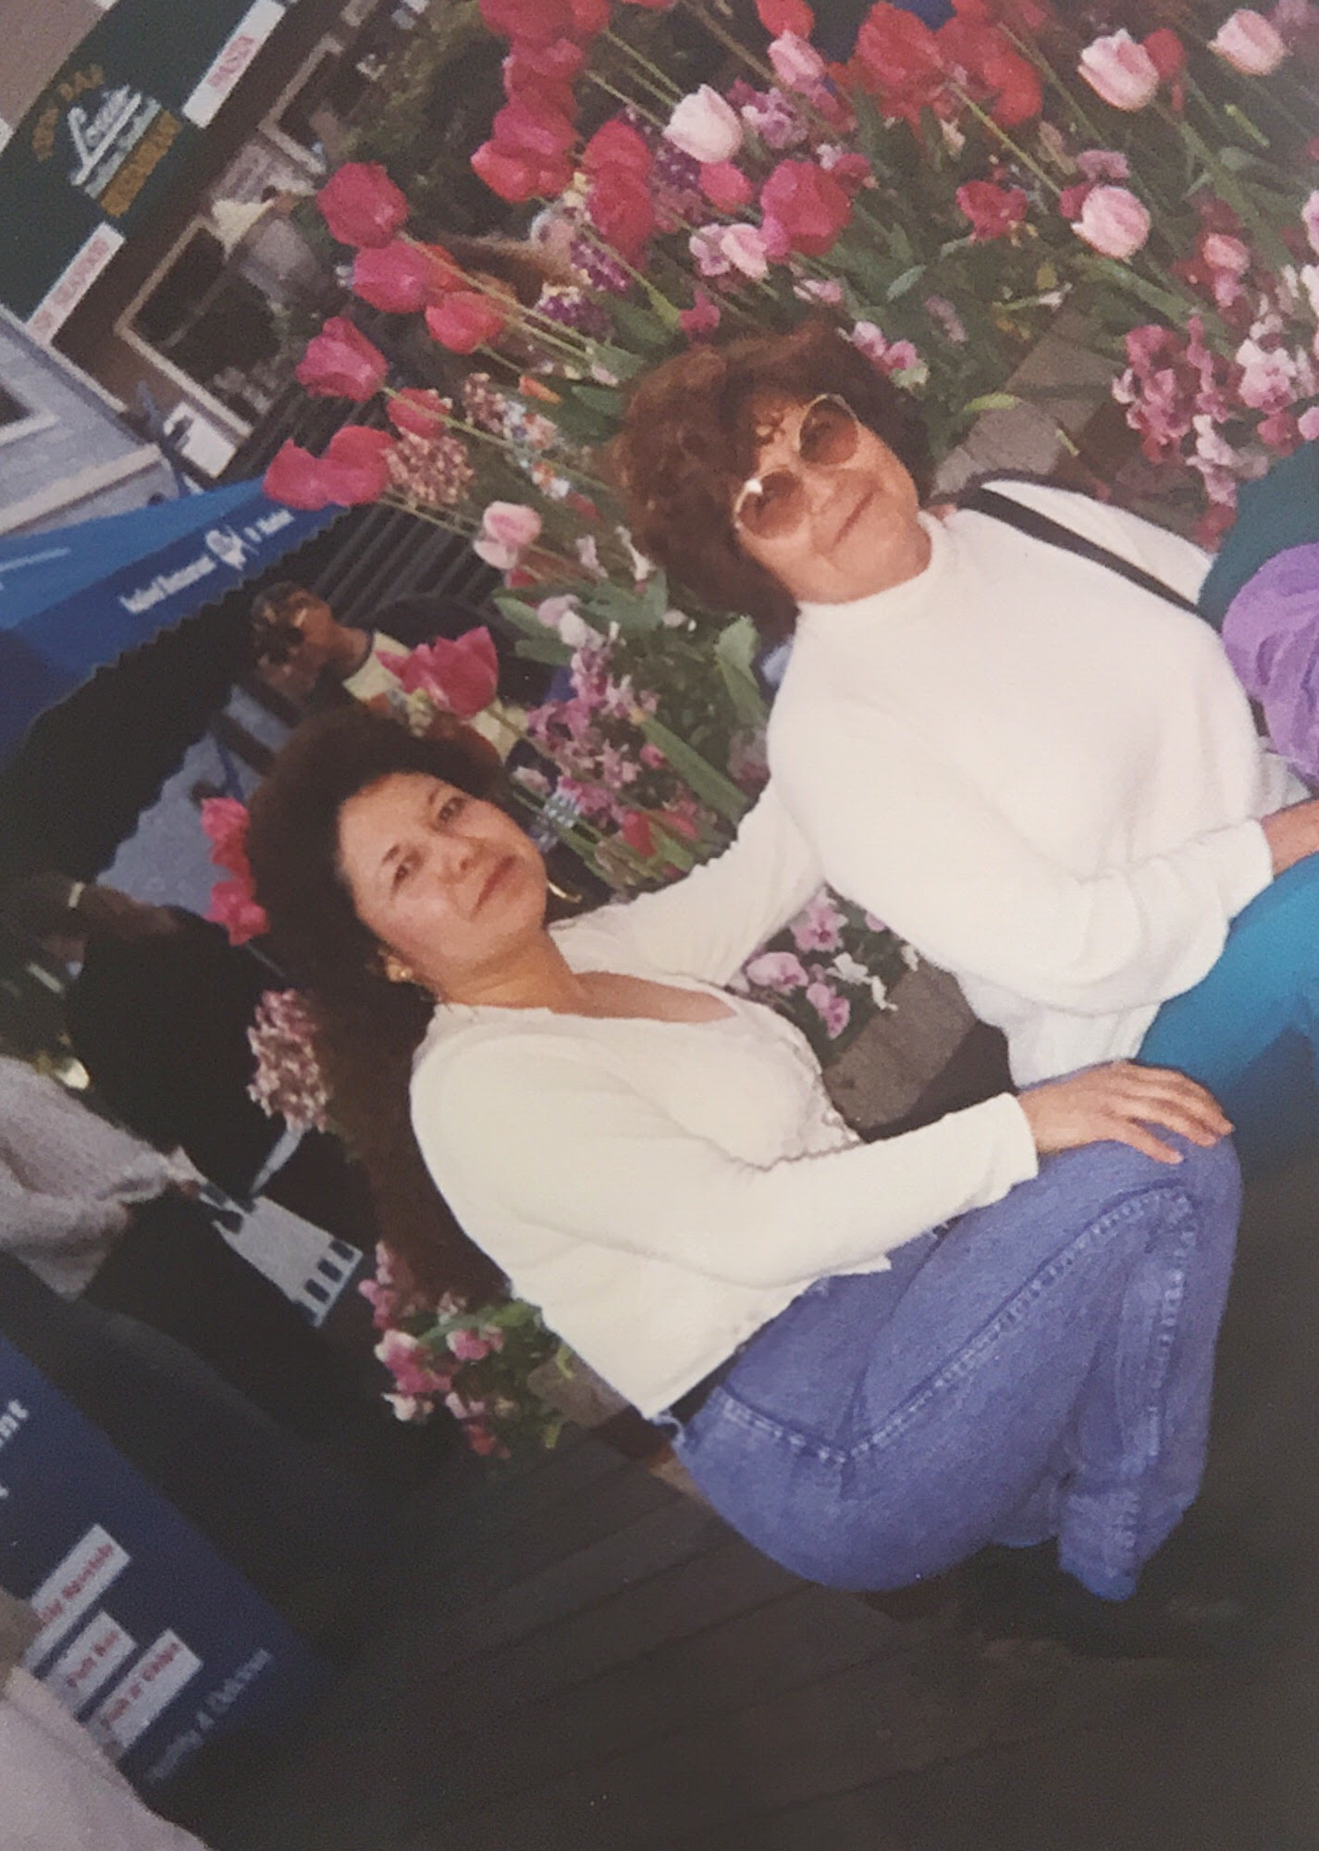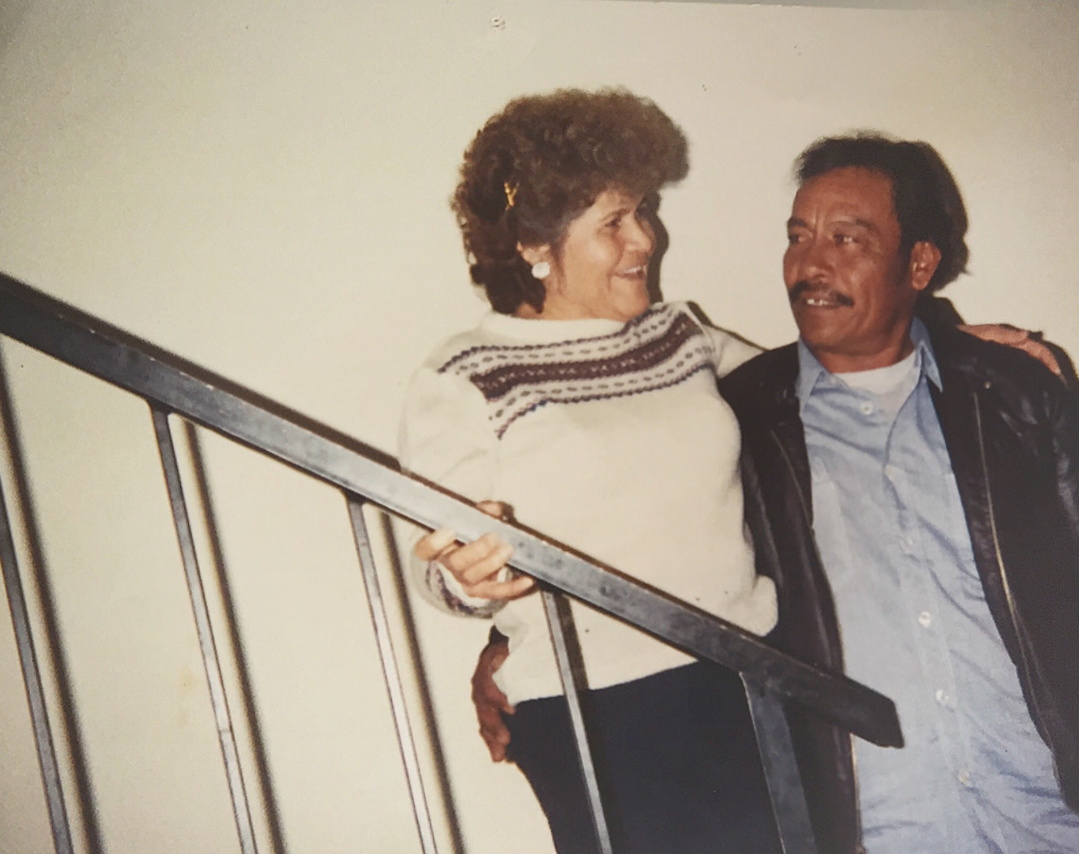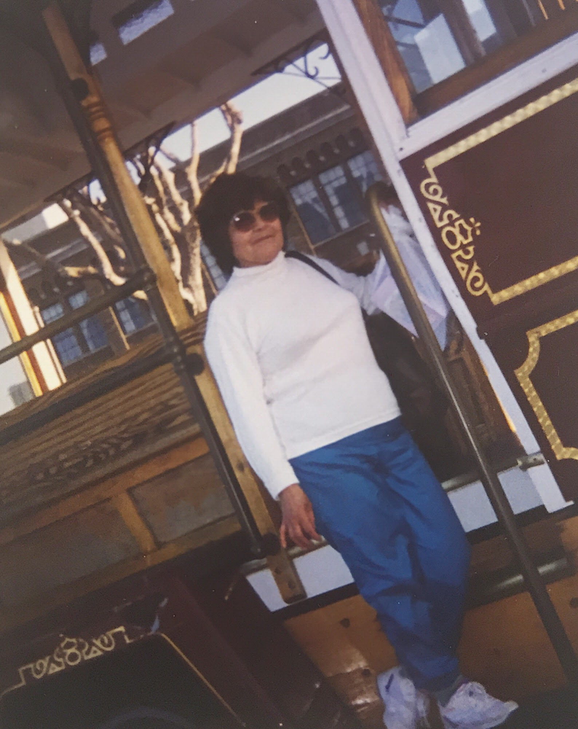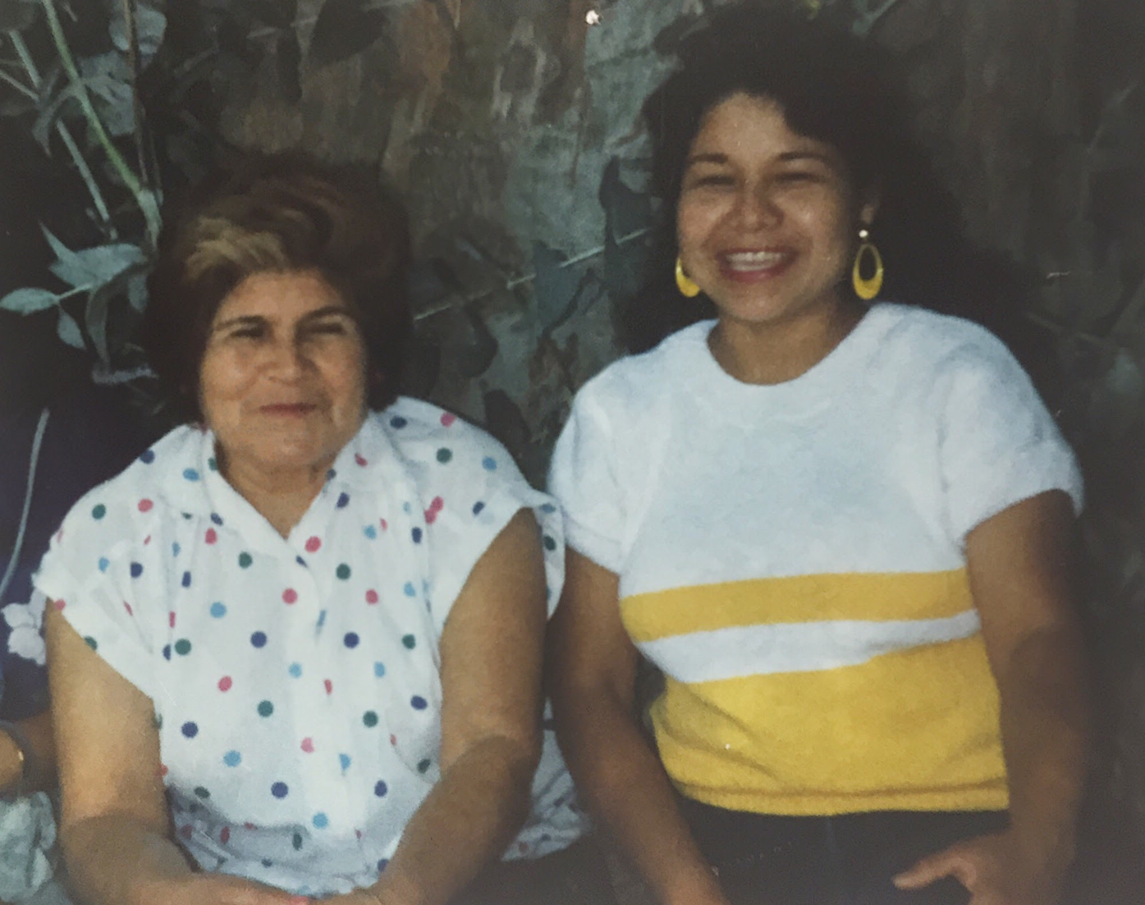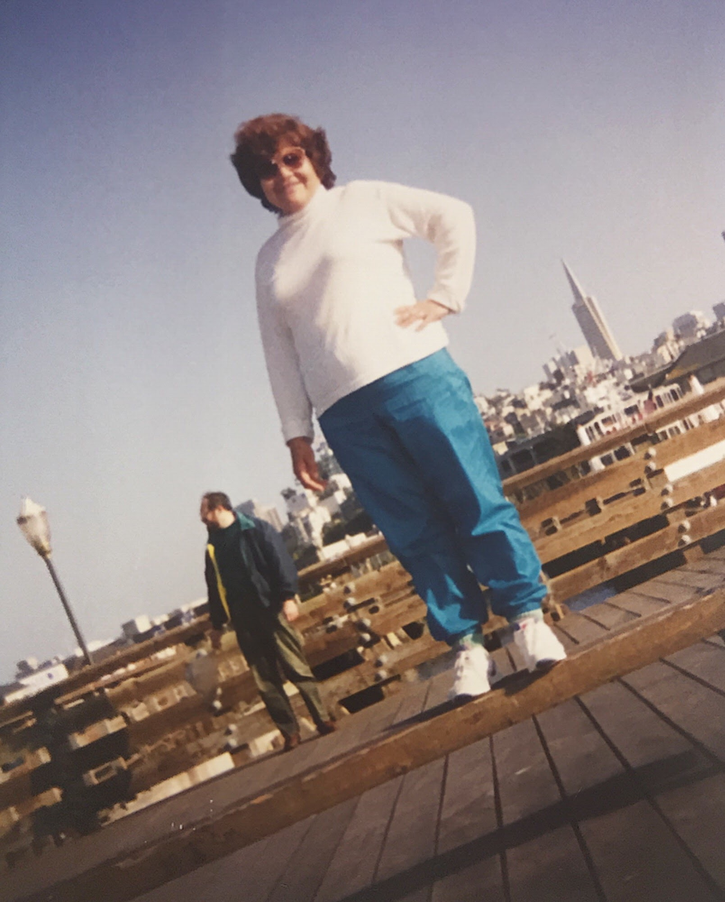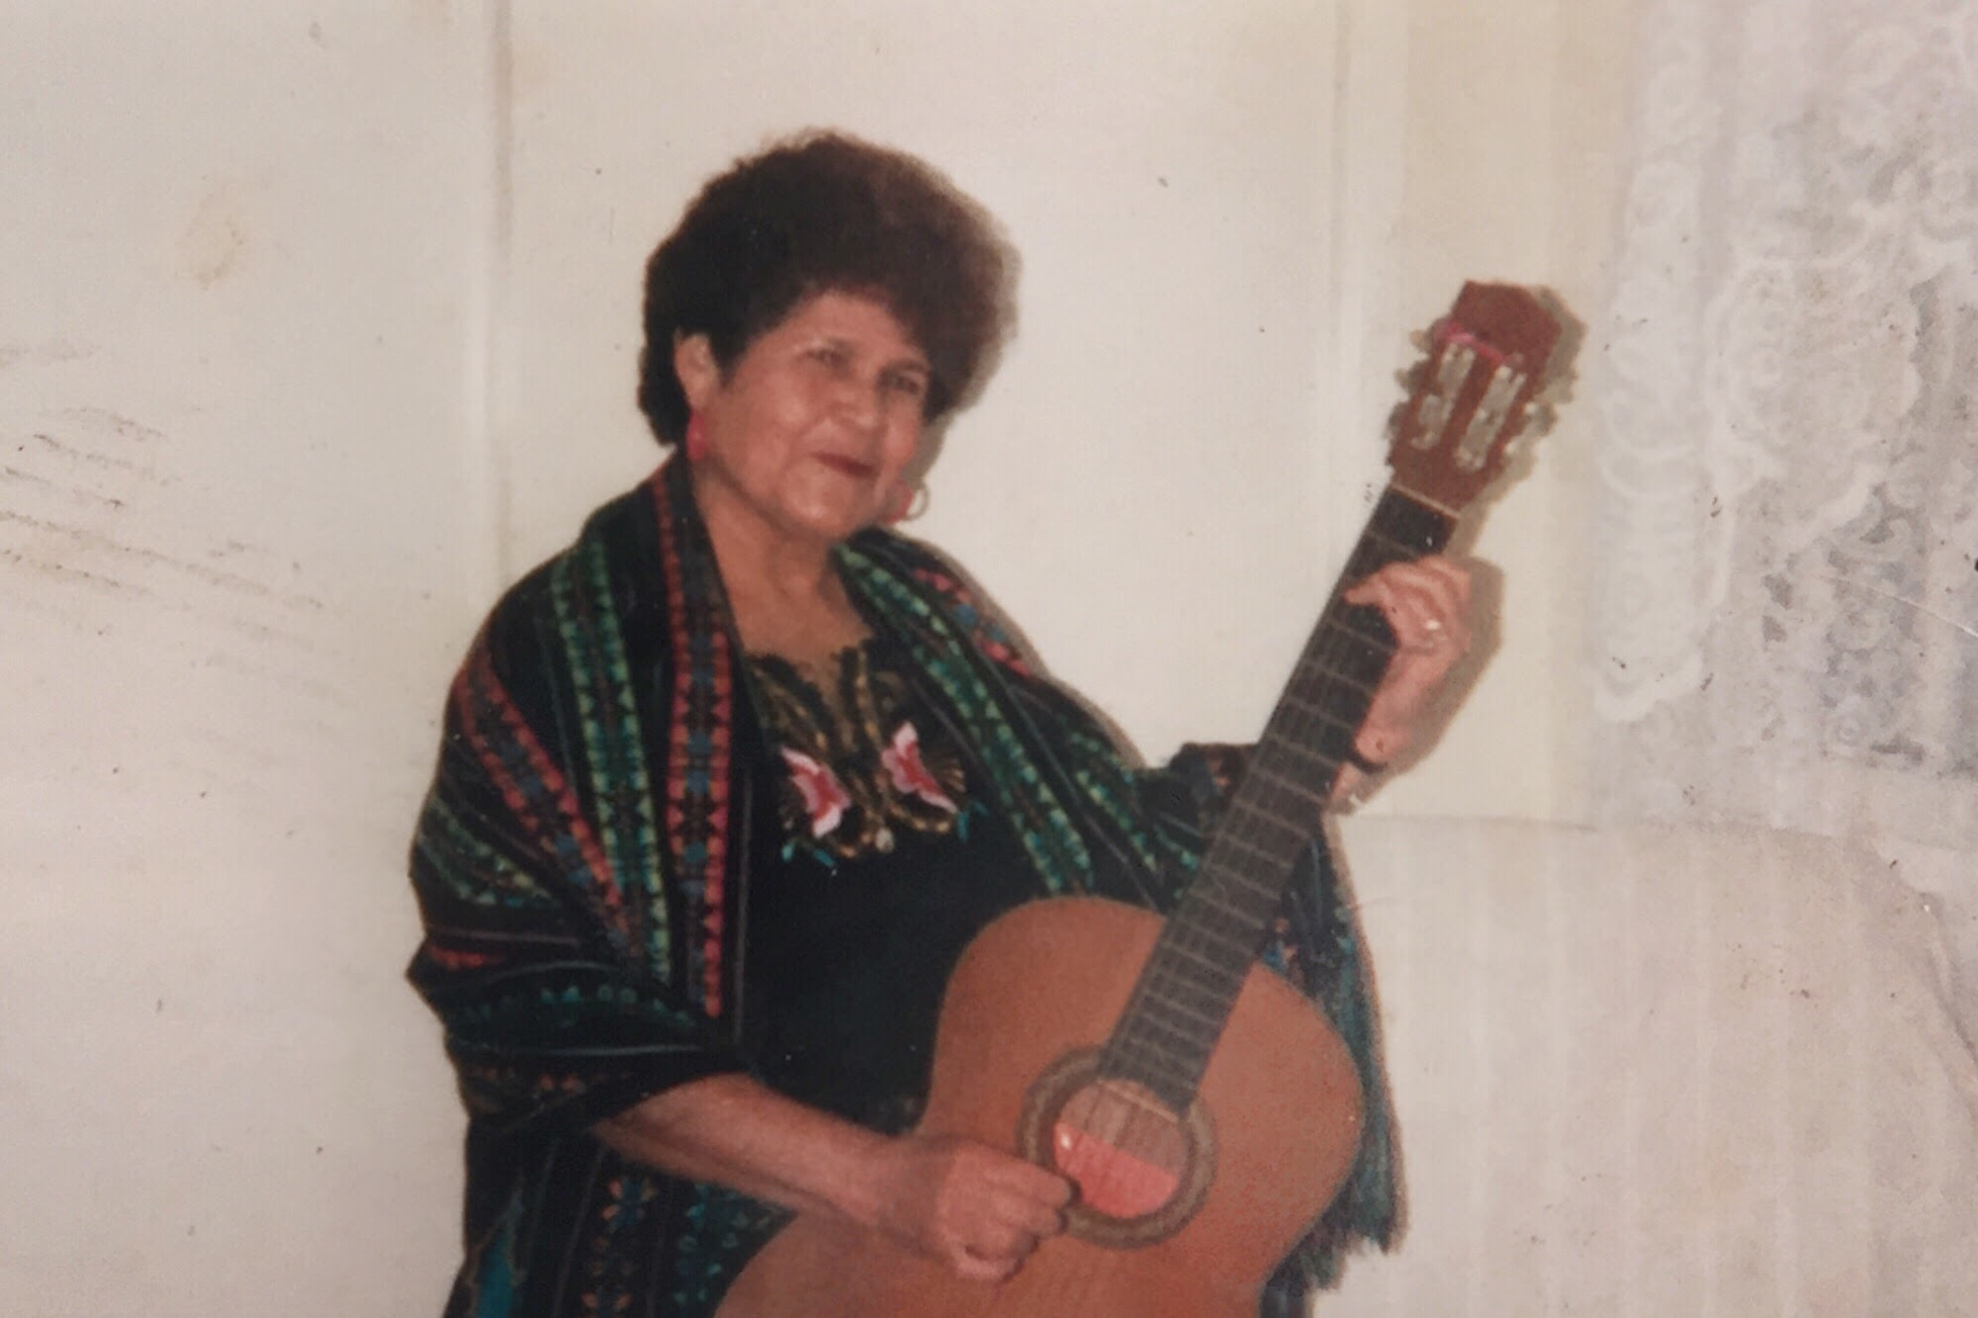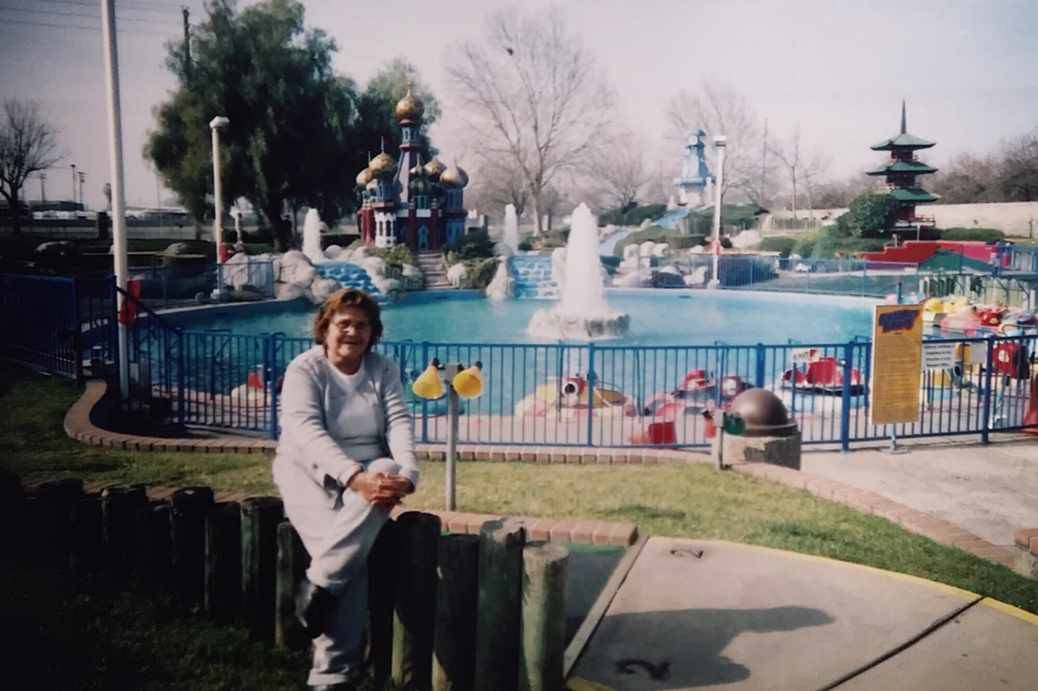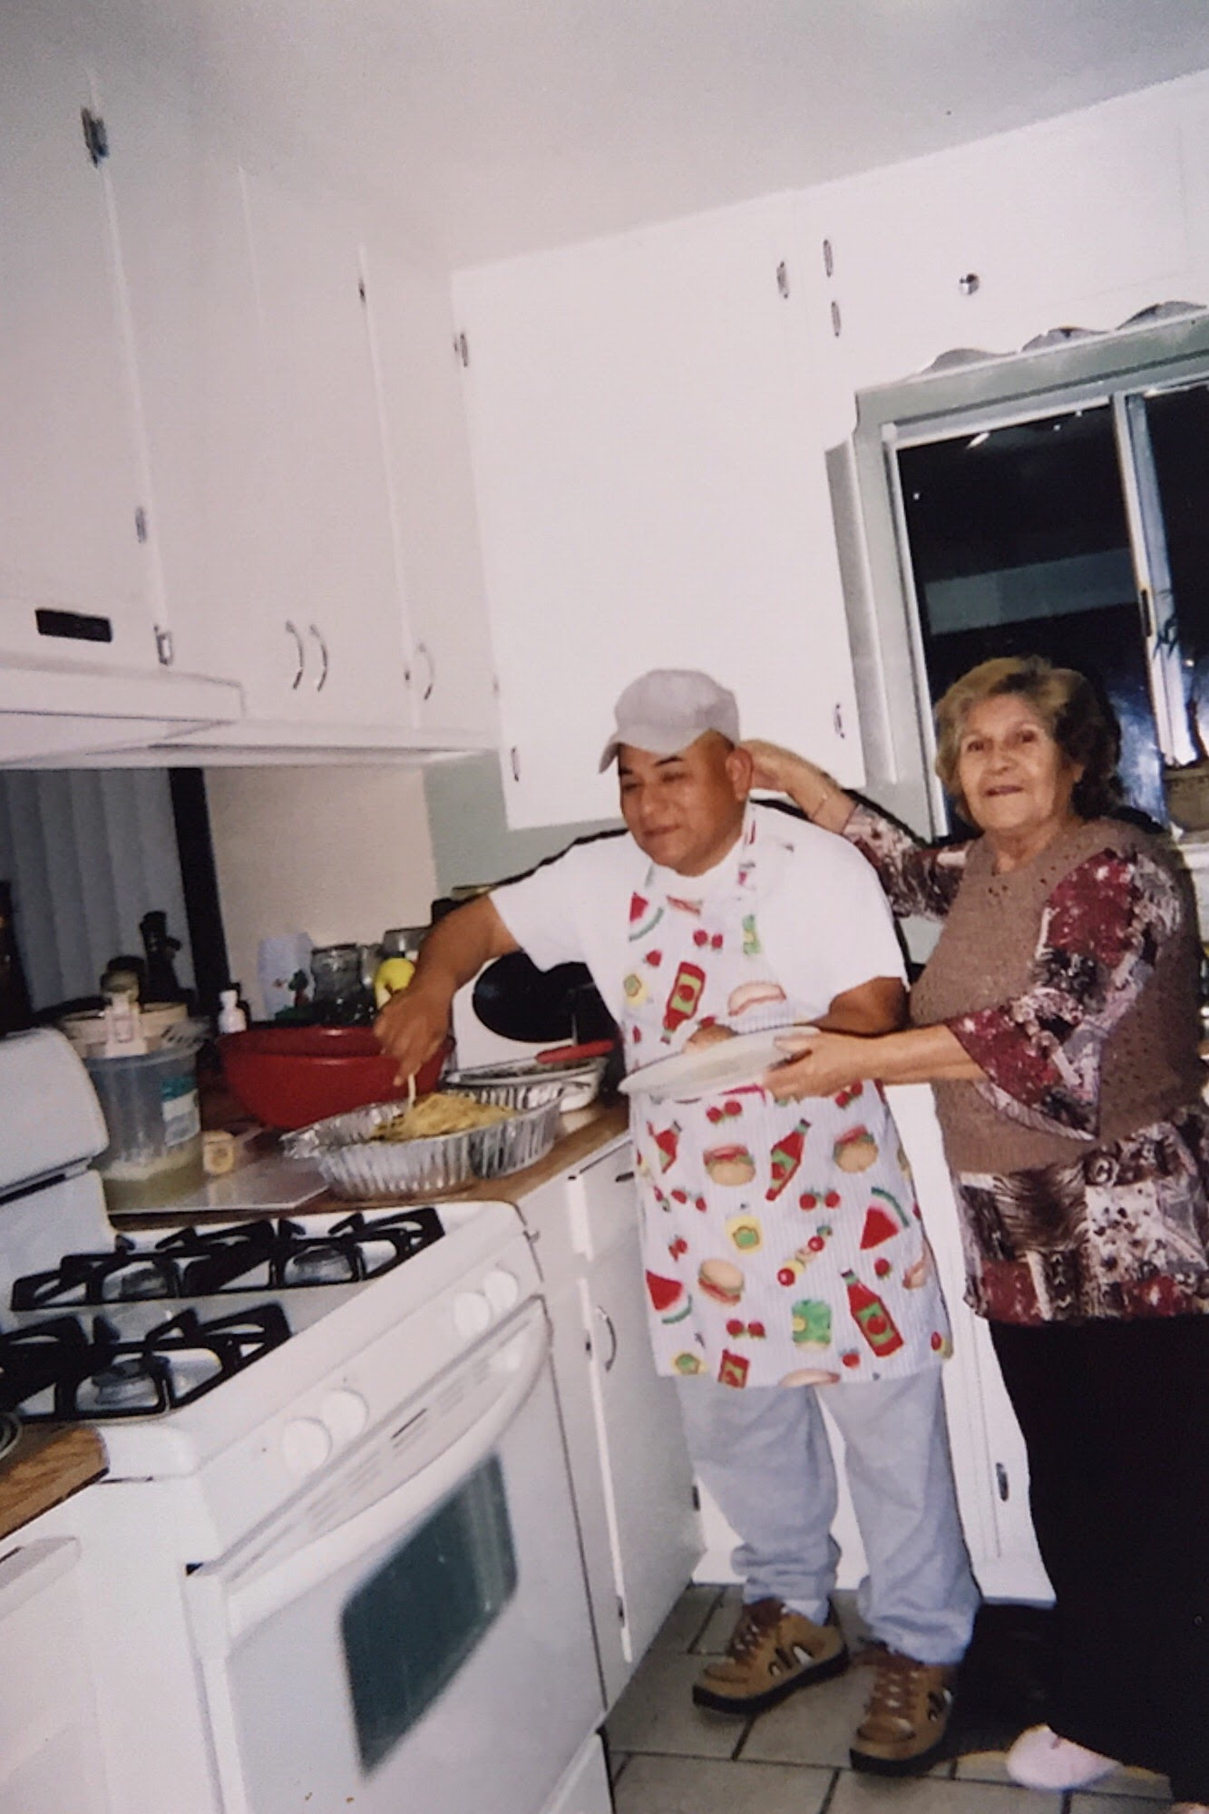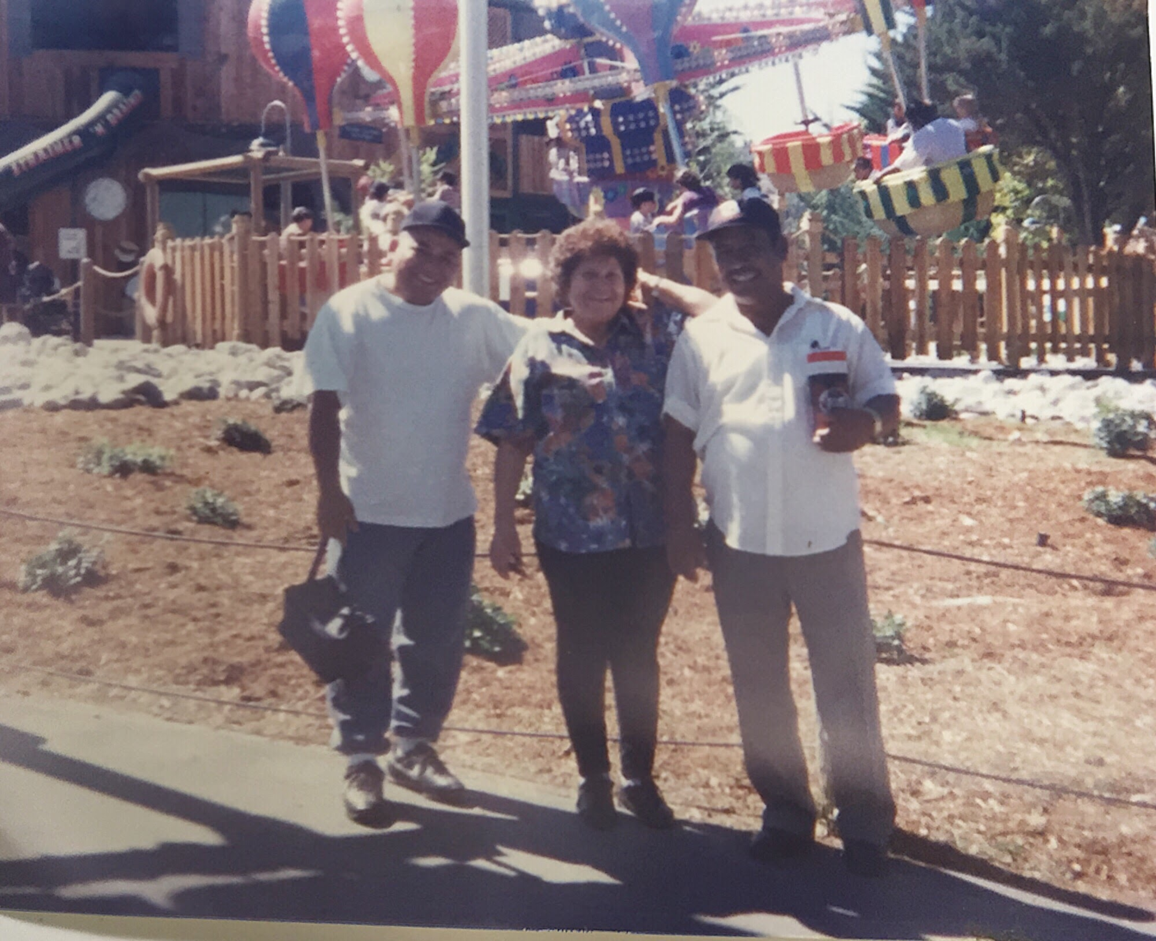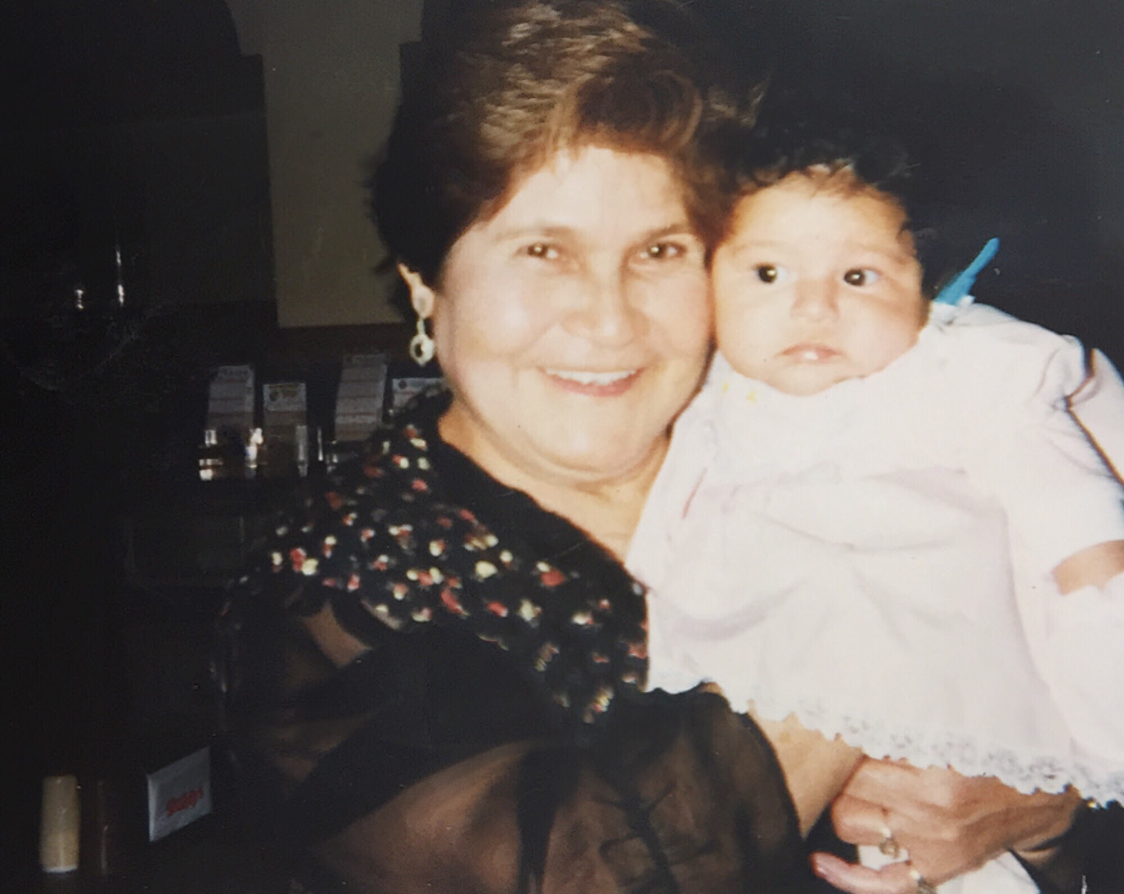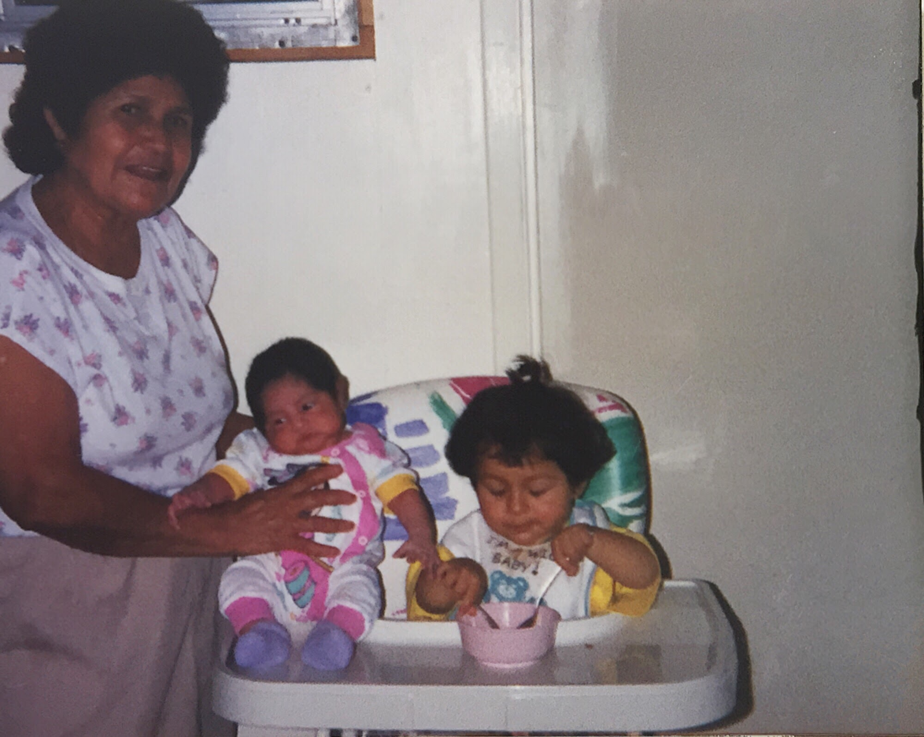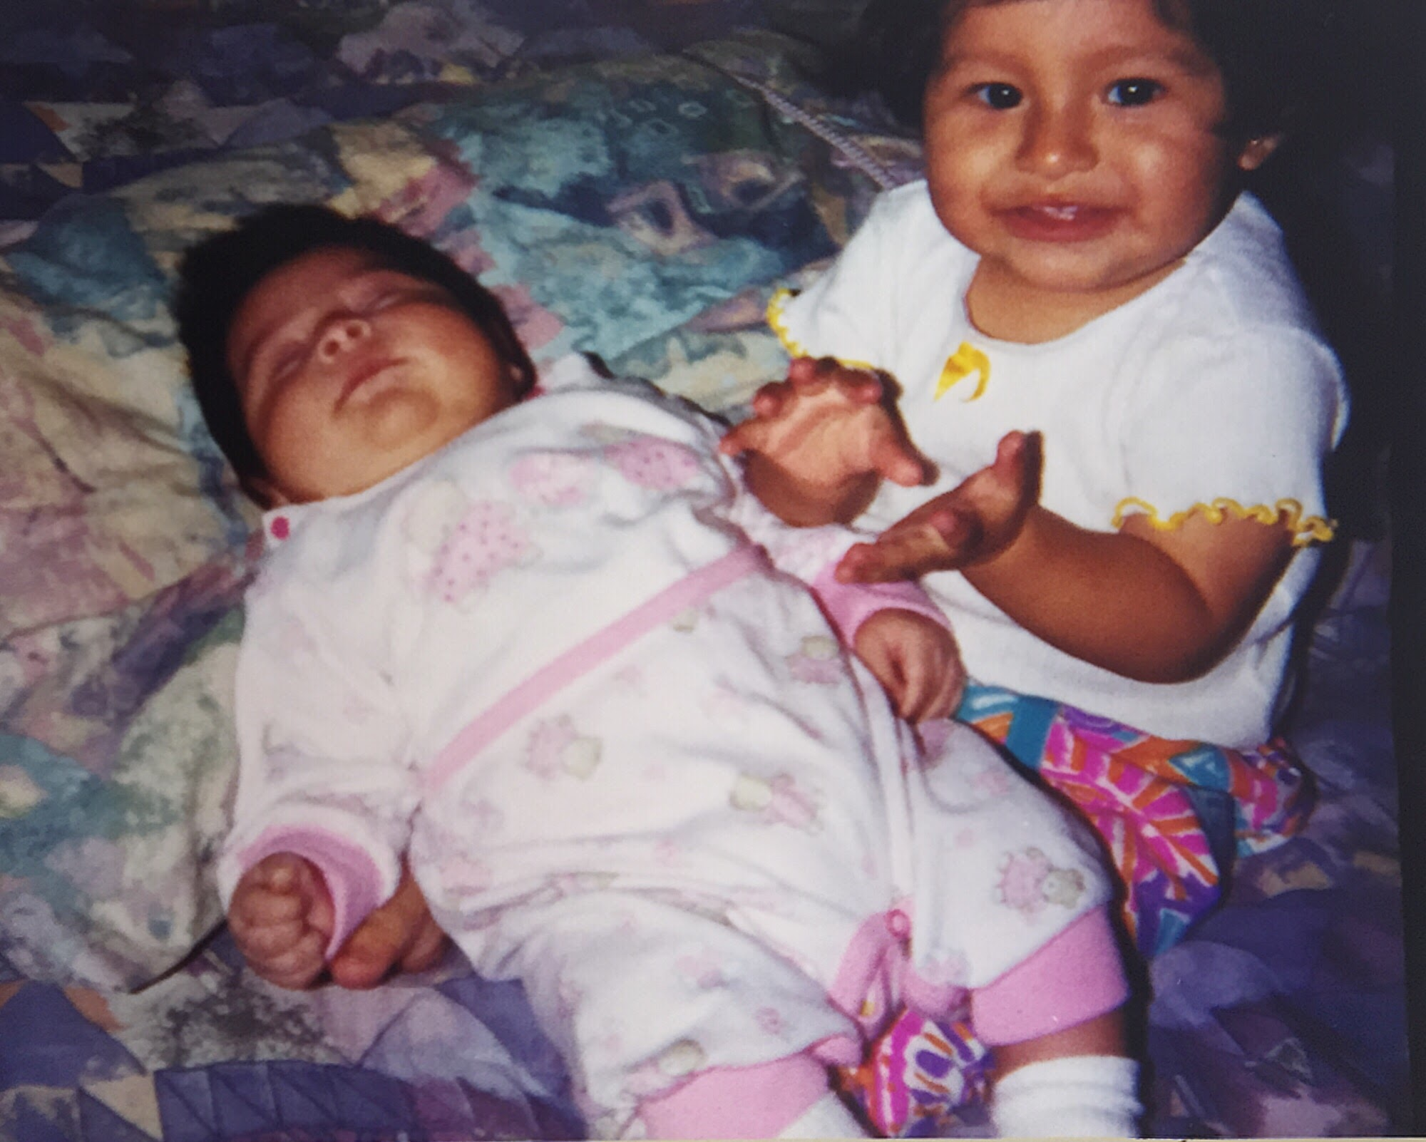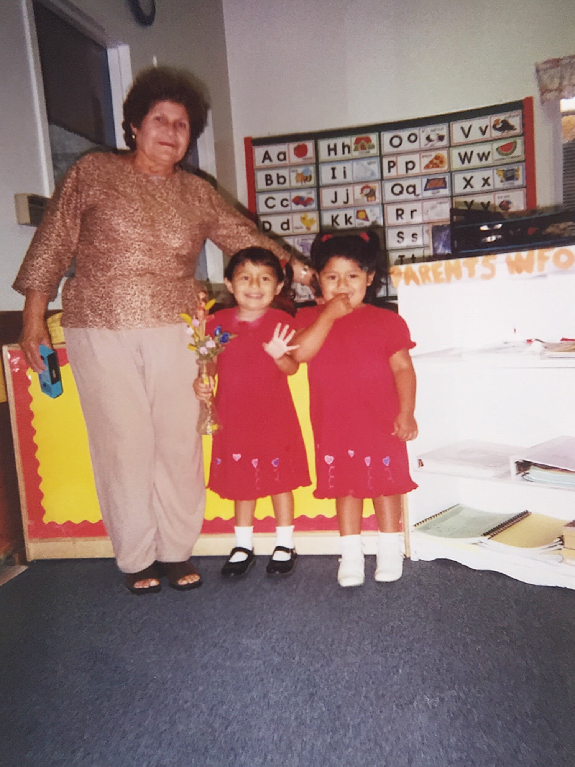

Milestone 2 (October 21, 2020)

Ever since my last milestone, I’ve been working on editing my images and getting them useable as textures for my butterfly models. This took a lot of time working in Lightroom and Photoshop, but eventually I managed to get them to how I wanted them (or as close to how I wanted them). Originally, I wanted to give the images an orange tint to resemble the monarch butterfly wing more, but I realized that it made it very difficult to see what was in the image since some of them were darker and/or faded. I ended up deciding not to make them orange, but I think they still turned out nice.

I also finished making the model of the bud version of the lilies. I made two colors to match the full bloom lilies. I also cut out and made my favorite of the photos into a plane which I think I’m going to use for the main image in my project. I’m thinking about having a nice field of flowers with the butterflies fluttering about around the image. My butterflies have animation for flapping their wings, but the flowers still don’t move. I think that I’ll be leaving them still so that I’m not placing too much into the New Art City room and causing lagging issues. I’m still trying to figure out how I want to place the flowers since I’ve been indecisive about how large I want them and what else I’ll be placing in the background of my butterfly garden image. What I think I’ll do is have some grass, my lilies, and the butterflies flying around my main image. Below I’ve included screenshots of my progress!

Here’s a screenshot of them all together:

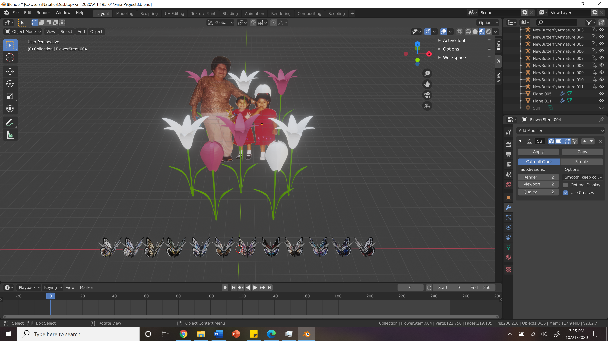

Just buds:

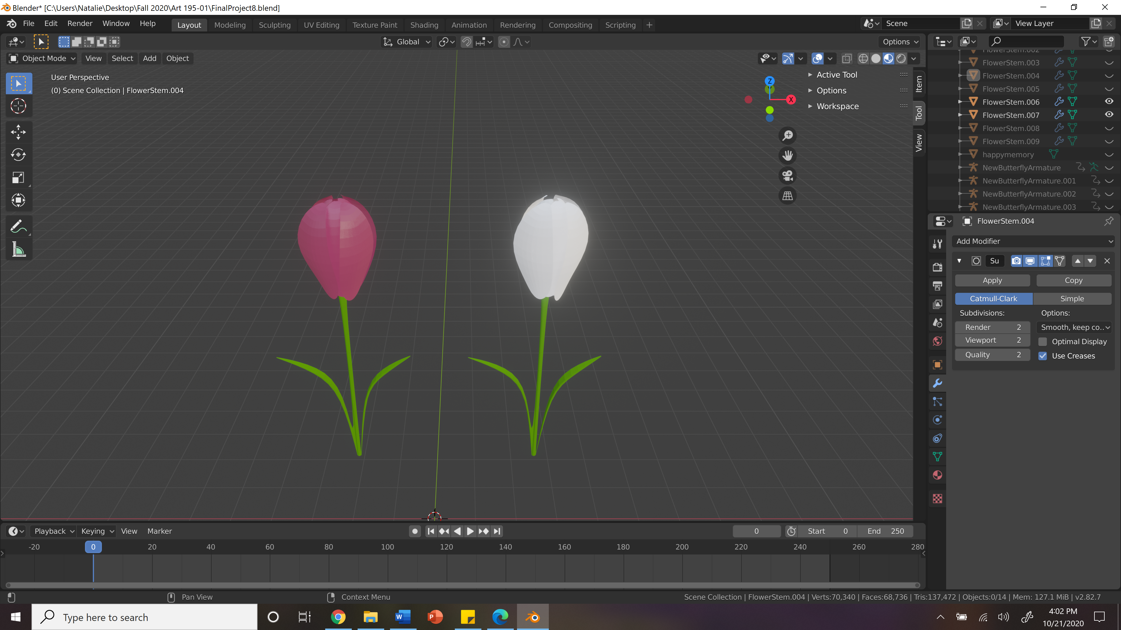

View of Butterflies at a later frame so wings are easier to see:

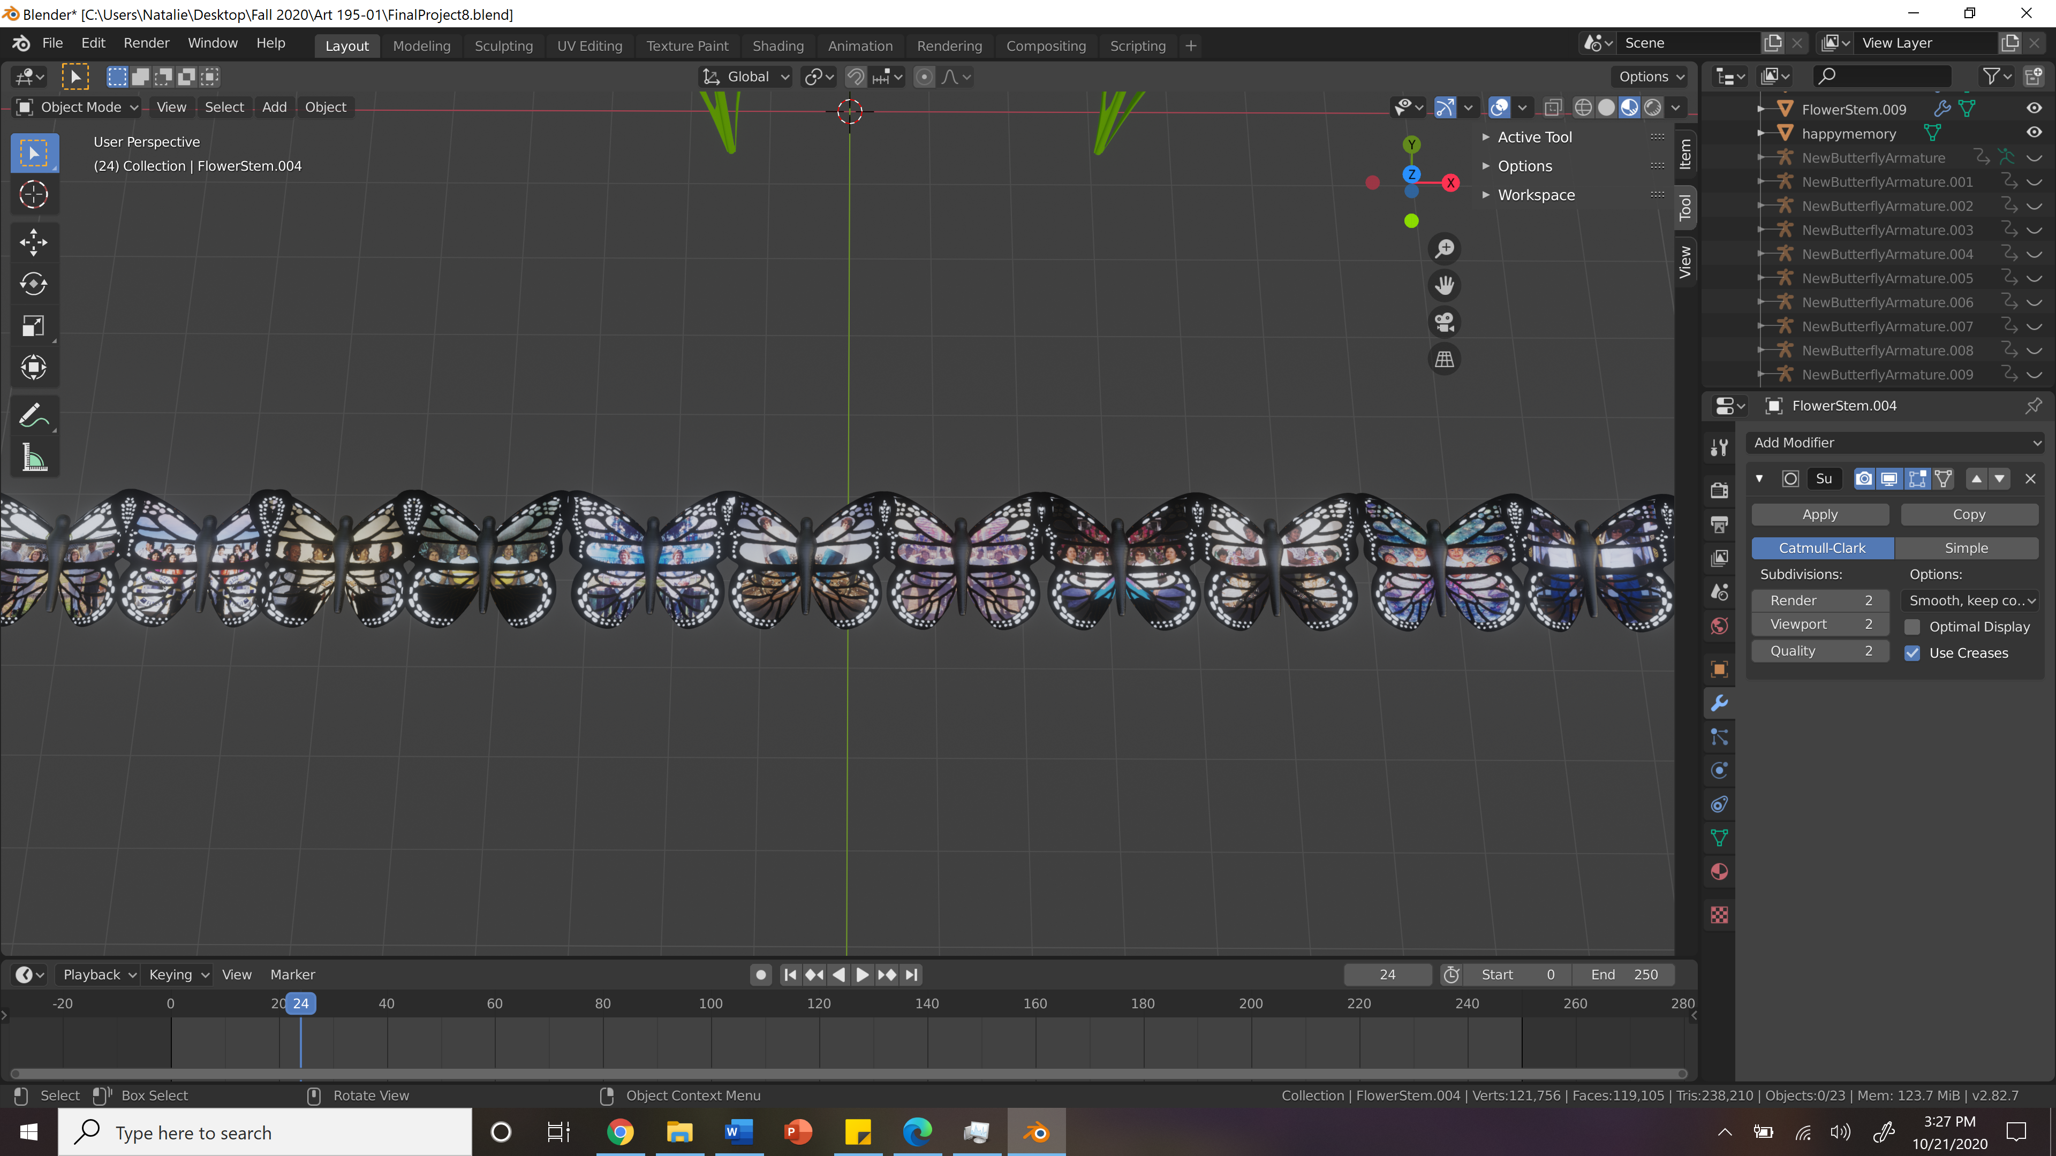

Close up of one of the butterfly wings (same butterfly used for model/animdation test on New Art City):

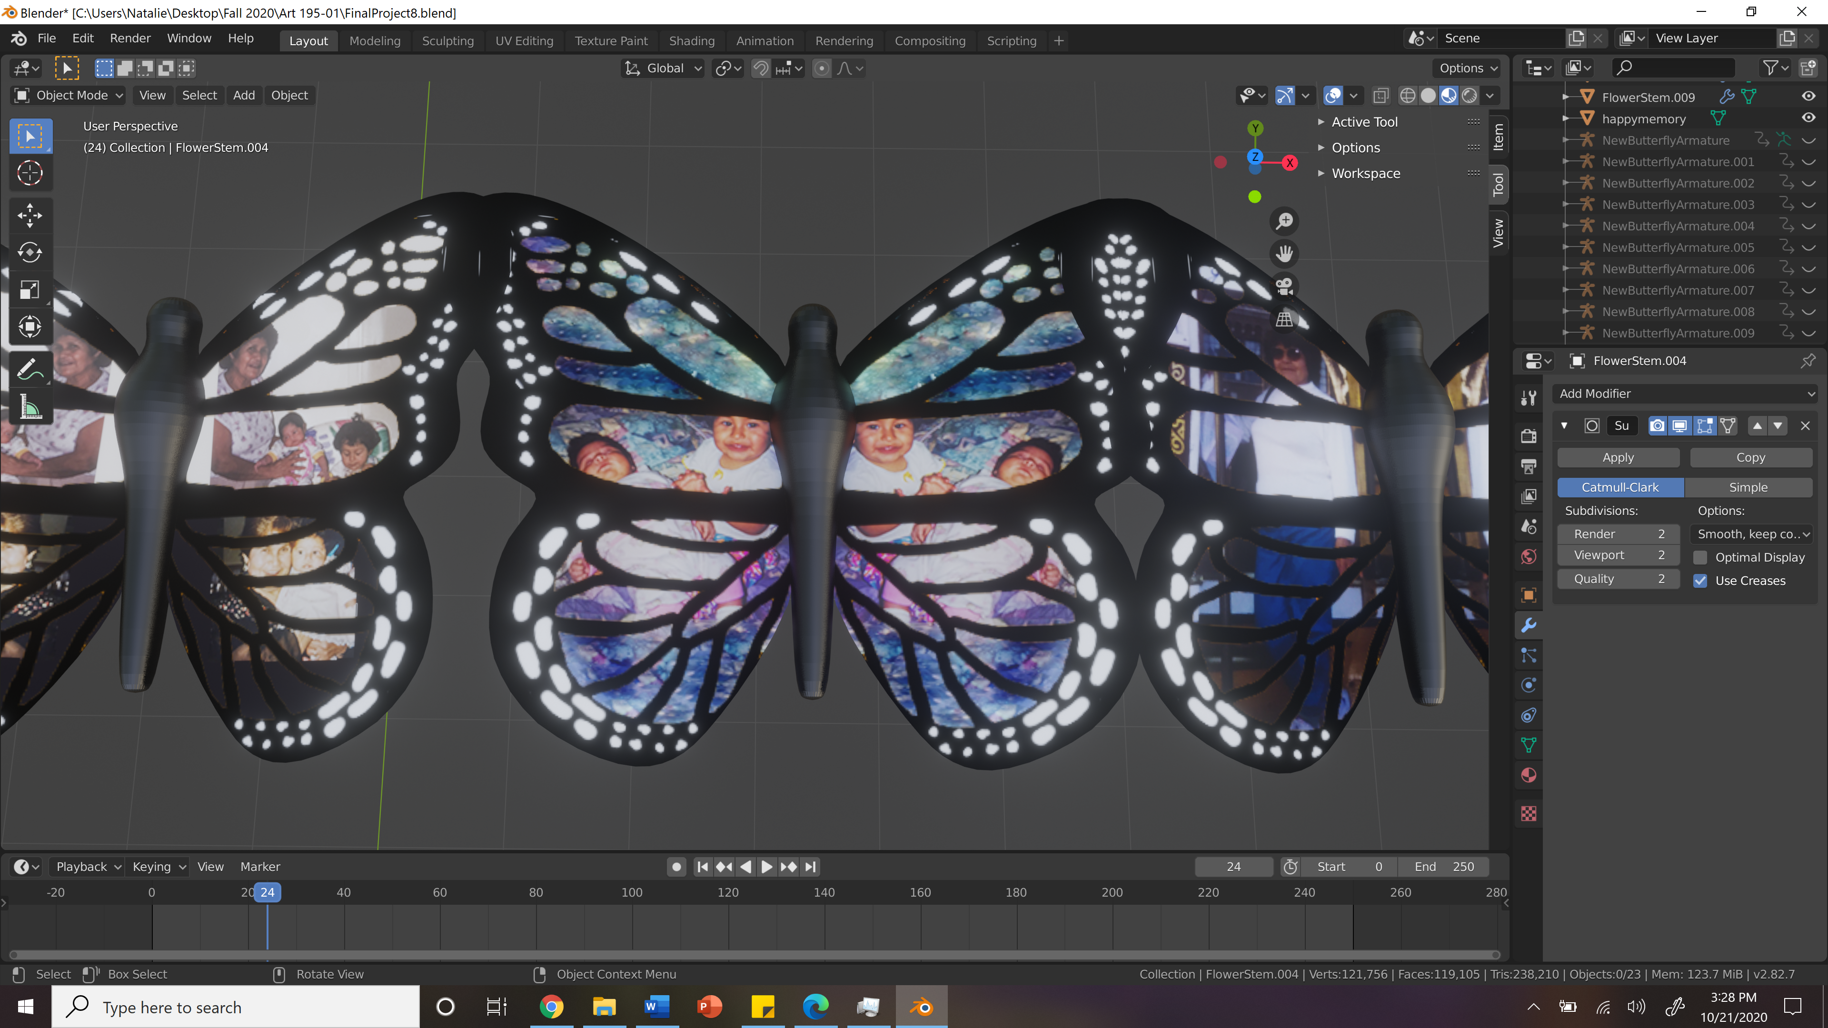

Room Test on New Art City (with image and model/animation tests):

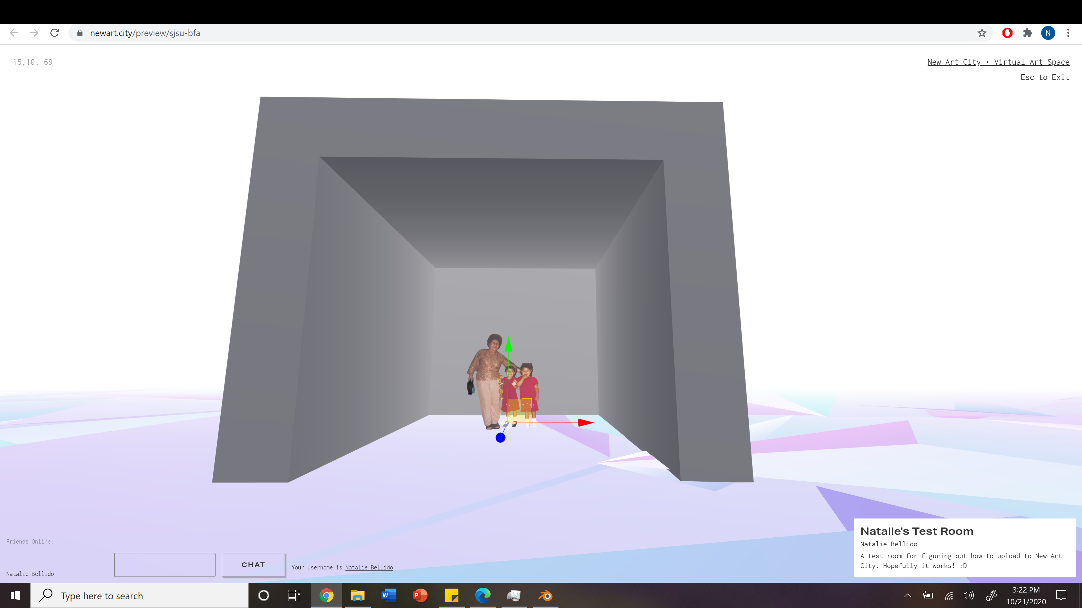

Close up of Model/Animation Test (same butterfly from blender screenshot for comparison):

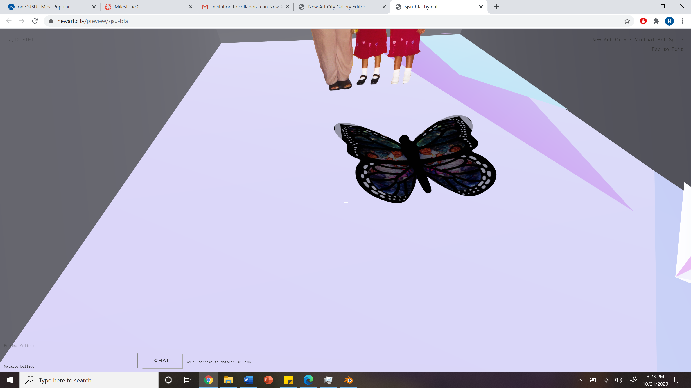

Edited images (right wing only for easier time scrolling through) :

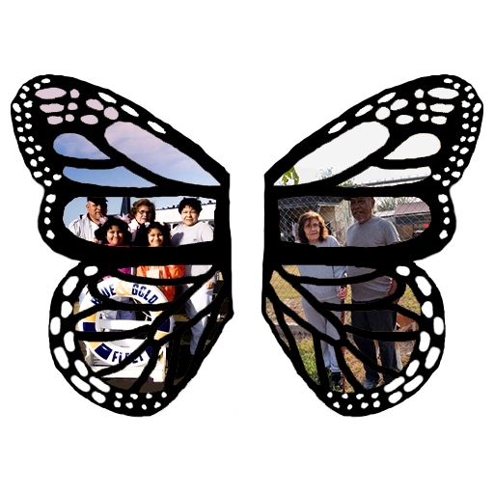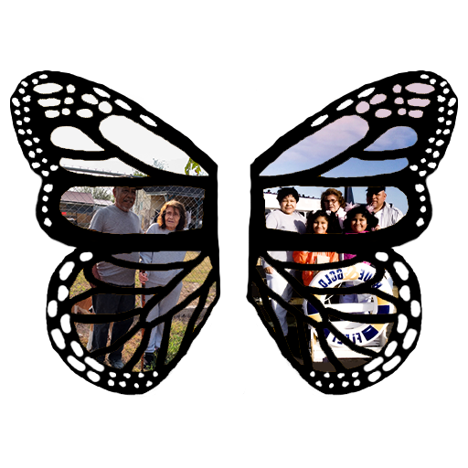

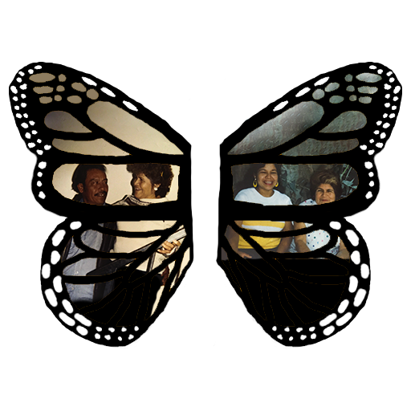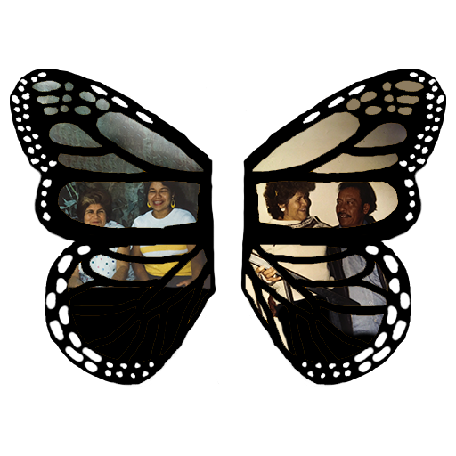

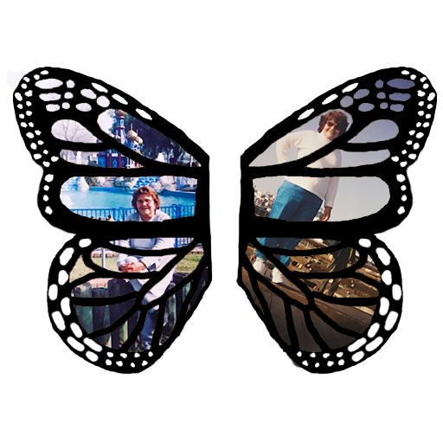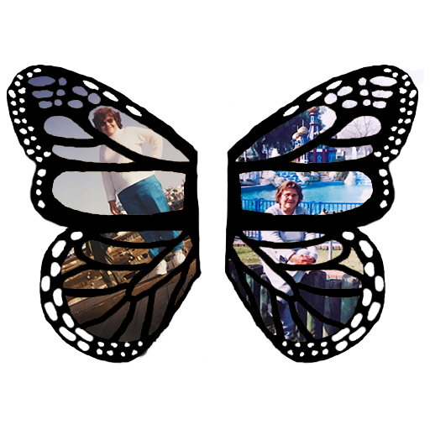

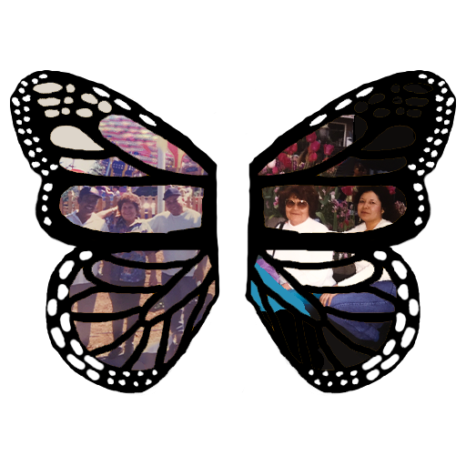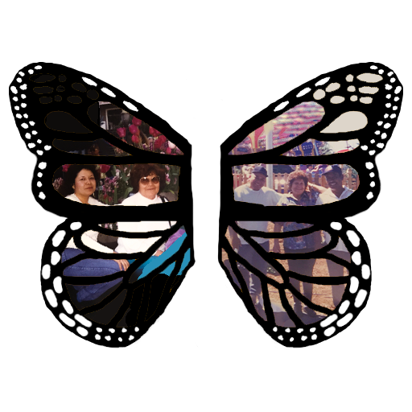

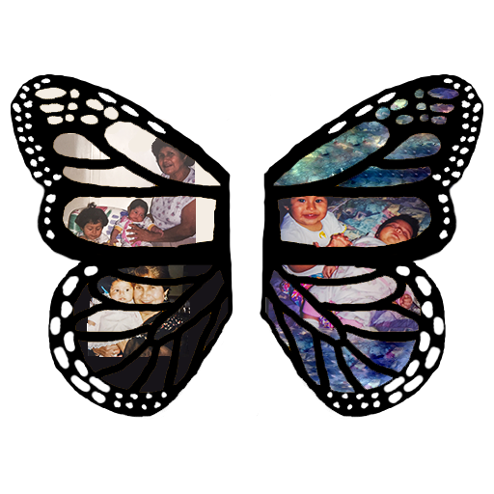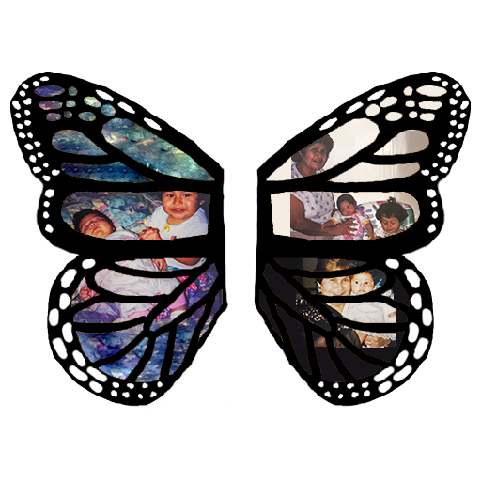

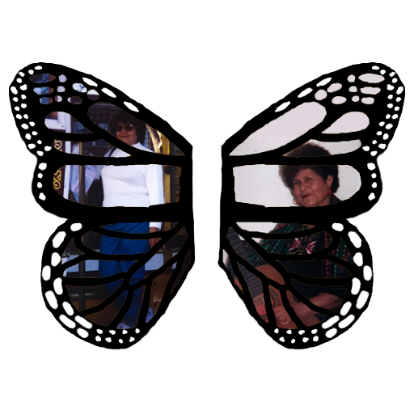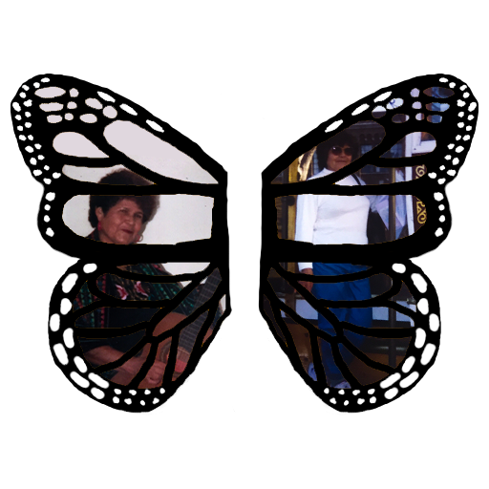

Final Version (December 4)

New Art City Room (outside room portal):

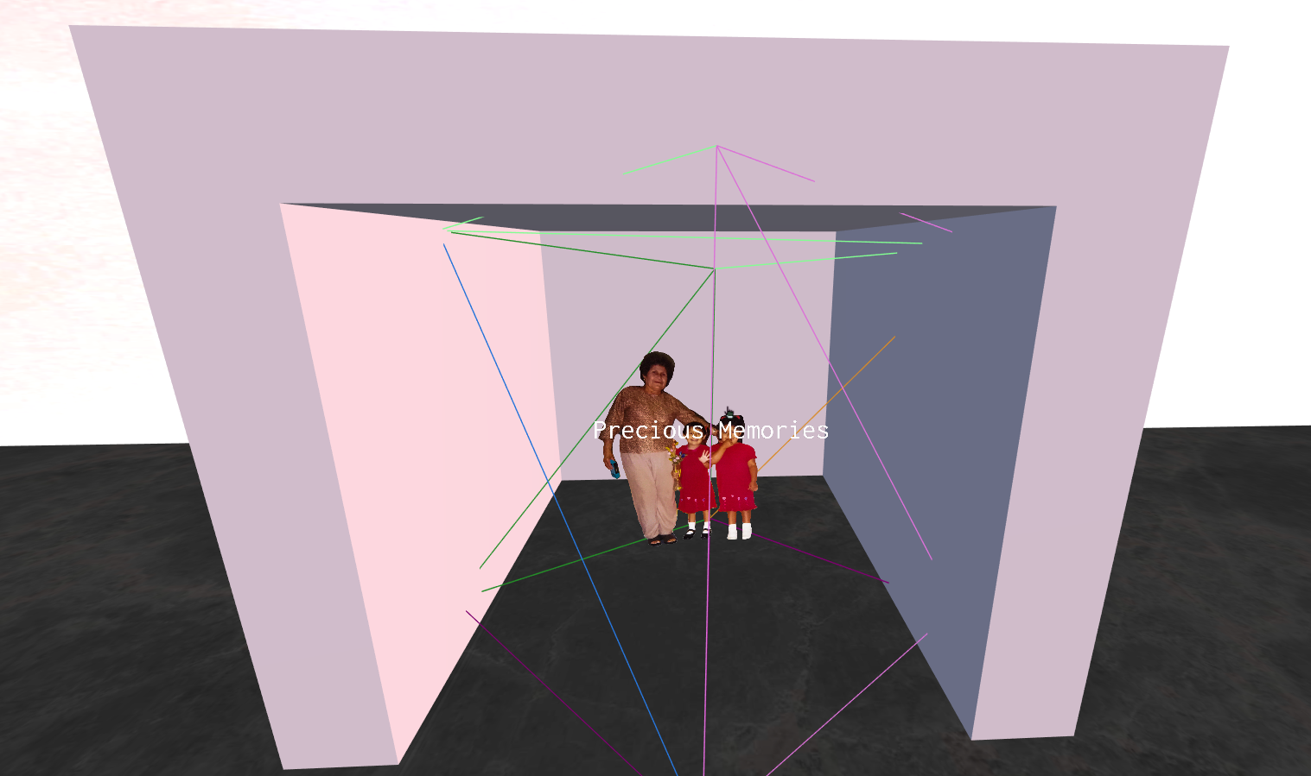

New Art City Room (inside room):

